**Position Paper on Cost associated with Hurricane Sandy**

**Student’s Name**

**Institutional Affiliation**

# **Introduction**

Hurricane Sandy made landfall in New Jersey on October 29, 2012, wreaking havoc on the populous metropolitan and very susceptible northern US East Coast with record catastrophic flooding and hurricane surge. This paper focuses on the cost associated with the project scope following socioeconomic recovery. It covers the features of the prompt and acute recovery of the region which was affected by Hurricane sandy, as well as constraints on recovery including the effect of the financial sociopolitical climates at the regional level.

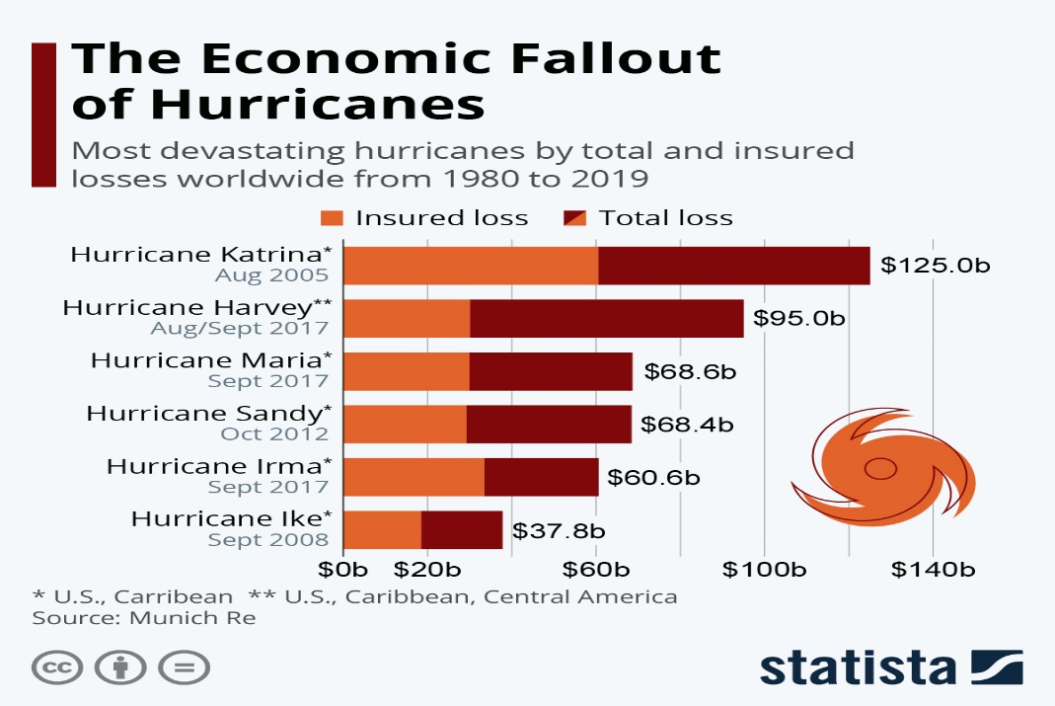

## **Cost associated with Hurricane Sandy**

Hurricane Sandy is one of the "biggest natural catastrophes" in terms of mortality and property damage, costing a total of $33.8 billion in repair and restoration expenditures and $9.2 billion in preventive and mitigation costs. Over 350,000 residential areas were destroyed or damaged, costing $9.8 billion to rebuild or repair, $3.2 billion of which was spent in New York City alone. Businesses lost $7 billion as a result of the administration's response actions, which cost $1.7 billion. It's crucial to understand that these estimates include two sorts of expenses: direct costs associated with the destruction of tangible assets like houses, autos, buildings, and highways, and indirect costs associated with the loss of commercial activities as a result of the upheaval.

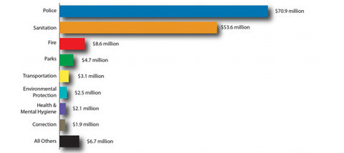

## **Physical Damage: Direct Costs**

Direct expenses reflect the region's major harm in the immediate aftermath of the storm. Based on one estimate, the total cost will be $35 billion, with the majority of it occurring in the tri-state area. Consider the physical damage caused by Hurricanes Andrew and Katrina, which totaled $45 billion and $137 billion, correspondingly.

## **Immediate calamity relief and finance**

Following a presidential proclamation of a state of crisis, state and local administrations may be eligible for FEMA (Federal emergency management agency) funding. This may encourage state governments to seek national disaster designations rather than bear the financial burden on their own. Furthermore, neither the state of New Jersey nor the state of New York possessed a calamity relief fund, posing a nationwide uncertainty. New Jersey and New York both declared a national emergency before Sandy's arrival. FEMA designated every county in New Jersey, as well as 13 counties in eastern New York, eligible for federal disaster aid.

Personal support for accommodation and other necessities was also offered to owners and tenants, including subsidies for temporary accommodation and home renovations, low-cost credit to offset insurance damage to properties, and other initiatives to aid people and business shareholders in their recovery from Hurricane Sandy. FEMA has received 247,328 personal aid applications in New York as of December 4, 2012, and had granted approximately $744.9 million in disaster assistance. In New Jersey, more than 258,353 people applied for assistance, and FEMA granted more than $273 million in disaster relief. FEMA awarded over $2 billion in disaster relief to over 500,000 applicants across all Sandy designations. However, after the tragedy, the speed with which federal relief was delivered and how inclusive it was to many impacted persons and properties was highly criticized.

The Disaster Assistance Appropriations Act, which offered a $55 billion package for disaster relief organizations, was signed into law in January 2013. The Disaster Relief Fund, which is the most urgent source of relief and rescue funds for Individual and Public Relief, received $5.5 billion from the fiscal package. The Transportation Department received $5.5 billion in funding, as did the Housing finance Agency Development ($5.5 billion), and the General Staff of Engineers ($1.45 billion). To keep the NFIP viable and prepared to afford the millions of incoming property requests, Legislators expanded FEMA's financing authorization by $9.8 billion (from $20.83 to $30.53 billion). The Sandy Recovery Reform Act of 2013 was also approved by Congress in response to difficulties with past recovery aid.

## **Grants based on Eligible Cost Estimates**

FEMA is now allowed to give public assistance funds to applicants based on estimations of their overall public assistance status under the potential alternative processes. The Stafford Act already gave the government the right to provide grants based on estimates of qualified assistance. In that statute, the President was tasked with convening an expert group to advise FEMA on how to estimate costs and issuing rules to execute these cost estimates methods. Even though an expert panel was created and a report was prepared, the statute's implementing rules have yet to be released.

Although possessing the capacity to give funds based on estimates in the past, FEMA reimburses public assistance applicants on an "actual cost" basis rather than estimations in the majority of cases. However, in general, FEMA only provides funds for PA projects based on those estimates when the project is projected to cost less than $68,500, making it eligible for streamlined processes under Section 422 of the Stafford Act.

# **Conclusion:**

Aside from the economic disruptions, the storm causedseveralf direct losses to inhabitants of the region that are likely to go unmeasured and unaccounted for. To begin with, around 140 persons in the United States died. People in the region also experienced anguish and suffering as a result of the loss of their houses and loved ones, as well as the numerous additional interruptions to daily life, such as time spent waiting in lines for fuel, longer and more difficult trips to work, and wasted perishable items. The full indirect costs of natural catastrophes are difficult to quantify and may be overstated since economic loss analysis often overlooks such expenses.

**References**

Opinion | Hurricane Sandy’s Rising Costs (Published 2012). (2012, November 28). Opinion | Hurricane Sandy’s Rising Costs (Published 2012).

Hurricane Sandy Facts And Information. (2019, February 11). Environment. https://www.nationalgeographic.com/environment/article/hurricane-sandy.